
W. L. Adams Center for Writing
FORMATTING PAPERS IN CHICAGO STYLE
(Notes and Bibliography Form)

“Chicago style” refers to guidelines for citing sources and formatting papers as set forth in The Chicago Manual of Style, 18th edition, a resource for writers and publishers.
Chicago style is used frequently in history, languages, theology, and fine arts. This handout also draws from Kate L. Turabian’s Manual for Writers of Research Papers, Theses, and Dissertations, 9th edition, which is Chicago style adapted for student researchers and their papers. Most professors requiring Chicago style prefer footnotes or endnotes, so this handout focuses on formatting these citations, known as the “Notes and Bibliography” form of Chicago style.

General Guidelines
Let’s start with the basics!
- Use white 8 ½ by 11-inch paper and black print.
- All margins must be 1 inch at left, right, top, and bottom.
- Double-space all text within the document except for block quotations, table and figure captions, and footnotes and endnotes.
- Use 12-point font for text and 10-point font for footnotes and endnotes.
- Choose a font that is readable; most prefer Arial or Times New Roman.
- Chicago style documents most commonly include “superscript” in-text citations that correspond to footnotes or endnotes.
- Number all pages in the upper right-hand corner of the page, except the title page. You will begin your numbering with a “2” on the first page of text.
- Include an alphabetized bibliography of the sources you quote or consult at the end of your paper.

Citing Sources in Chicago Style
Chicago style offers two options for formatting in-text citations:
  - Notes and Bibliography (either footnotes or endnotes)
  - Author-date parenthetical citations and bibliography.

Formatting Notes/Superscripts
- Cite sources using a superscript after any summary, paraphrase of your own words, or direct quote. Microsoft Word will auto-install superscripts in a smaller font, so you can then type the citation in the designated space
- If using a PC, select the “References” tab then choose between footnotes or endnotes.
- If using a Mac, select the “Insert” tab then choose between footnotes or endnotes.
- The software automatically sequences and adjusts the font size of superscripts.
- If you cut or paste text containing superscripts, the software will re-number the sequence automatically.
- Auto-formatted endnotes will contain superscripts rather than the numerals with periods which are also acceptable in Chicago style.
Marie-Louise’s lineage presented her as dynastically potent, a term that encompasses the power of her descent, natal family, and the potential production of her womb.4
4 Lindsay Dunn, “Creating Napoleon’s Dynasty: Marie-Louise, House of Habsburg-Lorraine, and the Art of Statecraft,“ Eighteenth Century Studies 53, no. 2, 257. doi:10.1353/ecs.2020.0008.
In your first citation of a source, provide information in full. Each subsequent time you cite that source, use only the essential features of author, title and page. This is known as the “short form.”

Footnotes:

Short form

1 Rebecca Sharpless, Grain and Fire: A History of Baking in the America South (Chapel Hill: University of North Carolina Press), 18.
2 William Meier, “Going to the Hoist: Women, Work, and Shoplifting in London, c. 1890-1940,” Journal of British Studies 50, no. 2 (April 2011):
430.
3 Sharpless, Grain and Fire, 23.

Endnotes:

Short form
Endnotes

1 Rebecca Sharpless, Grain and Fire: A History of Baking in the America South (University of North Carolina Press), 18.
2 William Meier, “Going to the Hoist: Women, Work, and Shoplifting in London, c. 1890-1940,” Journal of British Studies 50, no.
2 (April 2011): 430.
3 Sharpless, Grain and Fire, 23.

Formatting Direct Quotations
If a quotation is not a full sentence, or is less than 100 words, you can include direct quotes in your writing by incorporating them into your text.
Goethe credits the couple’s mutual devotion to, as Michael Yonan describes, their “humanity, their similarity to the late eighteenth-century German bourgeoisie, and to their sensibility, conceptualized both mutually and toward each other, and between them and their subjects.”¹⁰

Block Quotations in Chicago Style
If a quotation is 100 words or more, format it as a block quotation by indenting the entire prose extract 5 spaces. Omit quotation marks. If a quotation is more than one paragraph, format it as a block quotation by indenting the first paragraph flush to the left, but reflect original paragraph breaks for the other paragraphs in the quotation.
Introduce the quote by using a complete sentence in your own words, followed by the block quotation, single-spaced. To avoid “patchwriting,” do not use block quotes excessively or back-to-back.
Imbert de Saint-Armand describes Marie-Louise’s entry into Strasbourg:

At the bridge over the Rhine, which the Empress reached at five in the evening, she was met by twenty French generals and several divisions under arms. The bridge was decorated with flags; bells were pealing; salvos of artillery were roaring. At the entrance of the bridge the sovereign was welcomed by the Prefect of the Lower Rhine, and at the city gates by the Mayor.²

Formatting the Bibliography

A bibliography is a complete list of sources used in the paper; each source formally cited in Chicago style. Bibliography is placed at the end of the paper.

Alphabetize the list by author surnames. If the source has no author listed, use the title to determine where to place it in alphabetical order.
Begin each entry flush with the left margin, but indent subsequent lines 5 spaces for a “hanging indent.”

Chicago recommends the word-by-word system but will accept the letter-by-letter system. Under the word-by-word system, an entry for “Fernán Gómez, Fernando” would precede an entry for “Fernández, Angelines”; under the letter-by-letter system, the opposite order would prevail.

Bibliography

Aaslestad, Katherine. “Republican Traditions: Patriotism, Gender, and War in Hamburg, 1770-1815.” European History Quarterly 37 (2007): 582-602.
Boime, Albert. The Academy and French Painting in the Nineteenth Century. New Haven: Yale
University Press, 1986.
Lacan, Jacques. “The Mirror Stage as Formative of the Function of the ‘I.” In Ecrits: A Selection. Edited and translated by Alan Sheridan. London: Tavistock, 1977.

Sheriff, Mary D. “The Cradle is Empty: Elisabeth Vigée- Lebrun, Marie-Antoinette, and the Problem of Intention.” In Women, Art, and the Politics of Identity in Eighteenth-Century Europe. Edited by Melissa Hyde and Jennifer Milam. London: Ashgate Press, 2004, 164-187.

Formatting Annotated Bibliographies

Annotated bibliographies are common assignments in university courses. They follow the reference citation form of Chicago style but also include a short synopsis of each source’s content.
Annotations are often indented five spaces to maintain the “hanging indent.” In annotations, avoid repeating publication information already contained in the bibliographic entry itself.
Sheriff, Mary D. The Exceptional Woman: Elisabeth Vigée-Lebrun and the Cultural Politics of Art.
Chicago and London: University of Chicago Press, 1996.
Sheriff investigates the ways in which eighteenth-century society classified women artists as exceptional, and explores the mechanisms in place that stunted women’s artistic growth, ensuring that only a few could succeed. She uses the career of Vigée-Lebrun as a case study to understand how a woman artist acting in the public sphere negotiated gender norms, social institutions, and politics when creating portraits for the aristocratic elite.

Formatting the Title Page

Visualizing Queenship in the Rose Window at the Sainte-Chapelle, Paris

John Smith
Art History 10043: Introduction to Art History September 19, 2022

ILLUSTRATIONS IN CHICAGO STYLE
Figures:

- The Chicago Manual of Style defines “figure” as an “illustration” formatted “separately from the run of text.^{”1} Illustration’s can also depict data graphically, as in charts and graphs.
- Incorporate illustrations into the body of your paper near the first mention of them; however, in some disciplines that depend heavily on illustrations, such as art history, professors require figures to appear in a separate numbered list at the end of the paper but before the bibliography.
- Regardless of where your illustrations appear, each figure must be numbered sequentially in boldface Arabic numerals, accompanied by its unique title or caption.
- Include complete source information on figures in the caption and in your bibliography, formatted appropriate to the source containing the figure.
- Illustrations used for more than decorative purposes will need an alt text, similar to a traditional caption but describes what the image shows rather than merely what it is. If some of these details are included in the text near the image, the alt text can be shorter.
- If possible, mathematical expressions intended for the screen should be prepared as marked-up text rather than as images. Simple expressions in a nontechnical context may only require italics for variables while more complex ones should be marked up in MathML. Math that are presented as images must use a combination of words and numerals that restate the math in the alternative text.

Sample Figure:
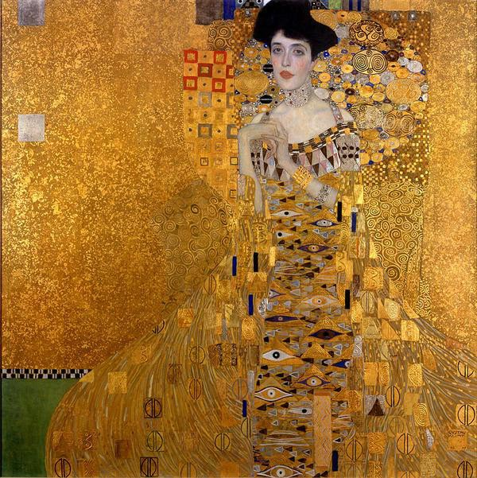
Figure 3. Gustav Klimt. Portrait of Adele Bloch-Bauer, 1907, Neu Galerie.

¹ “Illustrations Defined,” Chicago Manual of Style, 17th ed. (Chicago: University of Chicago Press, 2017), 126.

Sample Caption and Alt Text:

Caption

Gustav Klimt’s Portrait of Adele Bloch-Bauer I, 1907. Neue Galerie New York.

Alt Text

Painting of Adele Bloch-Bauer standing and immersed in gold leaf, a style popularized by Austrian artist Gustav Klimt, created by Klimt sometime between 1903 to 1907. Her dress is decorated with a pattern resembling eyes and round shapes and spirals surround her upper body, primarily shoulders and head. The only substantial space that is not golden is a patch of green in the bottom left corner. There are also small hints of whites, reds, pinks, blues, greys, and browns throughout the composition.

TABLES IN CHICAGO STYLE
- Charts intended for black-and-white reproduction should not be created in color, nor should charts that use color depend on them for meaning alone.
- Incorporate tables into the text of the paper. This guideline varies by discipline, and some professors or editors prefer you place tables in their numbered sequence at the end of the text but before the bibliography.
- Number all tables sequentially in boldface Arabic numerals, accompanied by a brief title containing key words about the content.
- Use text anchors or “callouts” to refer to a table only by its assigned number and title. For example: For an overview of the transatlantic slave trade, refer to Table 4.
- Charts published online or in eBook formats may require an alt text or extended description to ensure accessibility.
- Reproducing or adapting a table from another source? You must acknowledge the copyright of the source in a note below the table and in your bibliography.
- When two or more charts are used and deal with comparable material in a work, a consistent style in graphics and typography should be used.

SAMPLE TABLE

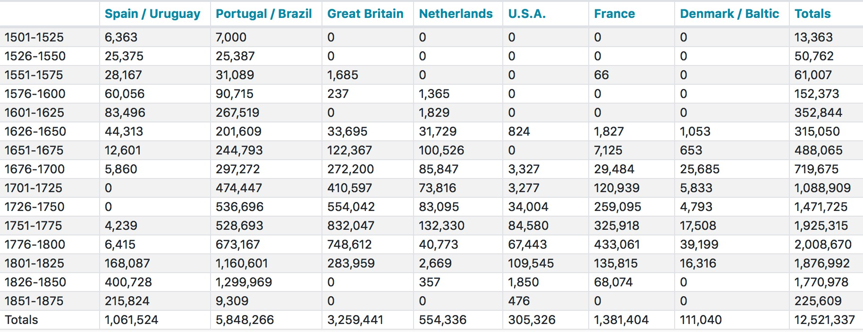
TABLE 4. Transatlantic Slave Trade by Country
Figure 7. A nine-column table depicting slave trade increase in 7 countries, with totals. Adapted from: “Trans-Atlantic Stave Trade Estimates,” Slave Voyages, July 2020, https://www.slavevoyages.org/assessment/estimates.


Visit our webpage for
more Chicago style resources.

